# Jonesboro Public Schools

# Pre-Kindergarten

# Program



Parent Handbook

2025-2026

Equal Opportunity/Non Discrimination:

*The Jonesboro Pre-Kindergarten Program and the Jonesboro Public Schools admits children and hires staff regardless of race, age, gender, disability, cultural heritage, marital status, political or religious belief.*

*JPS Pre-Kindergarten Program Page 2*

Jonesboro Public Schools

Pre-Kindergarten Program

**Pre-K Flint**

1307 Flint Street

Jonesboro, Arkansas 72401

Phone: (870) 933-5876

## Pre-K North

210 East Johnson

Jonesboro, AR 72401

(870) 933-5872

**Hours of Operation**

7:00 a.m. – 5:30 p.m.

Monday through Friday

## Pre-Kindergarten Program

The Jonesboro Public Schools (JPS) Pre-Kindergarten Program (Pre-K) for three-, four- and five-year olds emphasizes developmentally appropriate activities that address the child's individual needs. The program is based on providing a safe, healthy, stimulating, and well-supervised environment for every child.

## The Pre-K offers

Regular School Day Program (7:45 a.m.-2:45 p.m.)

Extended Day Program (7:00 a.m.-5:30p.m.)

## Pre-K Supplies Needed

* Lightweight sheet or blanket for naptime (Not for ABC students)
* Complete change of clothing In a Ziploc bag or paper sack with your child's name written on the bag.
* Standard size backpack (Not for ABC students)

Please make sure that your child's items are **labeled** with his/her name.

The Pre-K is **not** responsible for lost or stolen items.

## Enrollment Procedures

1. Attend a drop-in Open House to meet the teacher, visit the facility, and receive a parent handbook.
2. Submit the following for your child's file:
   * child's birth certificate
   * immunization record
   * Social Security card
   * proof of physical
   * proof of income (1 month of consecutive check stubs and last tax return)

## Withdrawal from the Program

Parents must give one week written notice regarding the withdrawal of a child from Pre- K. Withdrawing a child for vacation and requesting re-admittance will not be allowed. If a child misses 10 nonconsecutive days with no communication with the staff, the child is automatically dropped from the program.

## School Calendar

The Pre-K Flint is in operation year-round, excluding holidays. The Pre-K Flint and North follows the JPS calendar adopted by the JPS Board of Education. The calendar of days in session for 2025-2026 is located on the JPS website.

The Pre-K will close due to inclement weather if JPS is closed. Please check local television, radio stations and social media for school closings. You will receive ALERT Now messages at the phone number listed as a contact number for your student. You may also follow twitter at @jpshurricane for updates or Jonesboro Public Schools on Facebook.

## Attendance

Regular School Day: 7:45 a.m.-2:45 p.m.

Extended School Day: 7:00 a.m.-5:30 p.m.

Regular attendance and proper arrival time are strongly encouraged.

ABC students missing five (5) days per semester or three (3) consecutive days without a doctor's excuse or excused absence will receive a letter from the Director discussing dismissal from the program. **For ABC children, arrival after 8:15 a.m. for 3 days will constitute one (1) day's absence.** The last step will be the ABC student being dropped from the Pre-K Program, after consulting with the Arkansas Better Change Program Specialist. Ten (10) days per semester without a doctor's excuse will result in the ABC child being dropped from the Pre-K program.

## Tardy/Late

Since tardy arrivals are disruptive to the entire classroom, it is important that every child arrives on time. Please notify the teacher in the event that it is necessary for your child to be tardy due to doctor’s appointments, transportation problems, etc. These types of tardiest for which the teacher has received prior notification will be marked “Excused”. If prior approval is not obtained, and this continues to be a problem, an attendance review will be made by the director.

## Discharge

The Pre-K reserves the right to discharge a child on the following basis:

* Non-adjustment after a pre-determined amount of time
* Disciplinary problems (Refer to Discipline Policy)
* Failure of payment (not ABC students)
* Two (2) checks returned by our bank for non-payment, including tuition or aftercare payments
* Non-cooperation of parents with policies
* Failure to communicate for ten (10) nonconsecutive days with school
* Child not being fully potty-trained (not ABC students)
* ABC Reg. 14.03 – ABC Students – a consult will be requested with ABC Program Specialist about available options prior to discharge

## Payment Schedule Payment Due on Monday each week

ALL tuition is paid through ProCare. Tuition is payable on the first day of attendance each week. A $10.00 late fee will be assessed for paying after Monday of each week. A late fee will be assessed for EACH week past due (not applicable to regular day ABC students).

The person who signs the registration agreement is responsible for paying all fees for the days that have been contracted, including any days the child misses for any reason (not applicable to regular day ABC students). The person who signs the registration agreement is responsible for making sure payments are up-to-date.

Tuition is **not** prorated for single days of the week. Pre-K tuition is based on number of days in the school year, not the number of days in a week. Each **Monday** the same amount of tuition is due. If a child is absent for illness or any other reason, tuition is still due each **Monday.**

If tuition or aftercare payment becomes two weeks past due, the child will be removed from the program. If our bank returns two (2) checks per semester, a child may be dismissed from the program (not applicable to regular day ABC students), or you will be required to pay with a money order.

## Health and Safety Policies

For Your Child's Safety

1. Parents must sign the student in and out each day. The signatures must be legible. These signatures are used for billing for ABC and CCDF students. Also, when the pre-k is monitored, agencies review these signature pages to validate student attendance. In the case of fire, tornado or other emergencies, the sign in and out sheets may be used as roll call.
2. A child shall be released from the facility only to persons authorized on the "Permission to Pick Up" form. Any legal documentation regarding whom a child is allowed to see, be with, or go home with, must be on file in the office. If the person is not identifiable by the classroom teachers, the adult retrieving the child must show a photo ID.
3. In the event of illness, vacation, or other absence please notify the child’s teacher by 8:15 a.m. through SeeSaw, so we will prepare enough lunches for our students.
4. Our school is equipped with two-way radios for communication purposes at recess and during the school day.
5. The doors to our building, with the exception of the front entrance doors, are locked at all times. Anyone wanting to enter the building, must enter from the front doors only, press the call button and check in with the office staff.
6. All faculty members are trained in CPR and First Aid.
7. Visitors to the Pre-K should sign the pink sign-in sheet at the front door of the facility. This is kept for documentation in applying for grants and for forms required by the state, and allows us to know what visitors are in our building at all times.
8. CELL PHONES: **Parents or workers** while loading or unloading children, by state law are required to **not** be talking, texting, or using a cell phone for any reason. **If you are talking on your cell phone you will be asked to park your car and escort your child to or from the building.**

For Your Child's Health

**Please pick your child up as soon as you are notified your child is sick.**

* 1. If you are notified your child has fever or is vomiting, your child will need to stay away from other children for 24 hours. Child must be fever free for 24 hours without medication.

* 1. All children must meet the minimum immunization levels required for children in childcare. For the health and safety of all children enrolled, the immunization requirement must be met.

* 1. If any child shows signs of illness, parents will be notified and expected to pick up the child. Please have a **current phone number** to be contacted on file at all times with your child’s teacher. If parents cannot be contacted, other adults listed on the application will be notified to pick up the student from school.
  2. Children shall be checked within 30 minutes of arrival for contagious or infectious diseases. No child shall be admitted if he/she displays any of the symptoms listed below. Parents or guardians shall be notified to pick up the child if he/she exhibits any of the following symptoms:
     1. Fever: any child with a body temperature of 100 degrees taken orally or 99 degrees taken under the arm.
     2. **Diarrhea: two (2) or more watery stools in a 24-hour period**.
     3. **Vomiting**: **two (2) or more occasions within the past 24-hour period**.
     4. Rash: body rashes, not obviously associated with heat or allergic reactions to medications.
     5. Sore Throat: if associated with fever or swollen glands in the neck.
     6. Generally not feeling well: child is listless or crying excessively.
     7. Head Lice: Children who have head lice will be sent home. In order for your child to return to school, the parent must bring his/her child to the Director's office or nurse before 8:00 a.m. Proof of treatment (empty treatment bottle) should be brought to the office. No nits present for return.
     8. Mucous: thick, green colored mucous
     9. Pink Eye: glassy, pink or red eye that itches or is painful to the touch
     10. Ringworm: not treated or covered
  3. School-wide head checks are conducted in the fall and spring semesters. Should your child be diagnosed with head lice, a phone call will notify you. Should a child in your child's classroom be diagnosed with head lice, a phone call or letter will notify you.
  4. If your child has been exposed to a communicable disease, a letter will notify you. Please update your child’s teacher if your child is exposed to or diagnosed with any contagious disease.

* 1. A child must be free of fever and vomiting for 24 hours from the time the student is sent home and fully recovered from an illness before coming back to the Pre-K center. This helps control infection in our school. You will be called to pick up your child if he/she returns to school before the 24-hour time period is complete.

* 1. Immediate treatment shall be obtained for a child who sustains a minor injury (scratches, scrapes, bumps, insect bites, etc.).

## In The Event of an Emergency

The JPS Pre-K Program prides itself on being a safe and healthy place for children.

There is at least one staff member present at all times who is certified in CPR/First Aid.

If a major injury to a child occurs, the staff will immediately call for professional help. Parents and/or the designated emergency contact person(s) or the child's doctor will be notified immediately. If the emergency is such that immediate attention is necessary, the staff will call an ambulance to take the child to the hospital. A staff member will follow until parent(s) or guardian(s) arrive. Parents will be responsible for all medical expenses. Parents are required to sign a "Medical Emergency Form" which is included in the registration forms.

## Administration of Medication

It is sometimes necessary for children to receive medication for illnesses and infections. Should your child require medication while attending school, you will be required to meet the guidelines below:

Prescription Medication: "Authorization for Medication" form must be on file in the office. Medication must be in the original bottle containing child's name, medication name, dosage, time interval, doctor's name and date.

Non-Prescription Medication (e.g., Tylenol, cough medicine, cough drops): Complete "Authorization for Medication" form and provide the written instructions including child's name, dosage, time interval and duration for administration.

Topical Medications (e.g., sunscreen, calamine lotion): Complete "Authorization for Medication" form.

Medication for Chronic/Allergic Conditions: If your child has a chronic or life-threatening allergy or condition (e.g., asthma, bee stings, peanut allergy), prescriptions and procedures for treatment must be kept at the program as long as the child is enrolled.

* Proper forms must be received before starting school.

The following procedures for medication must be followed:

* Expired medication will be returned to the parent.
* Emergency Medication: At all times at least one First Aid and CPR certified staff member will be present. Should a situation arise in which we are asked by a physician or poison control to administer a medication, we will do so under their professional instruction.
* Medications will be administered and documented by the staff. All medication will be in a locked cabinet. We recommend asking pharmacists for an additional labeled bottle to leave at school and to ask the doctor to write a "prescription" for any over-the-counter medications he/she may suggest. Please be advised that we will not administer medication to mask or alleviate symptoms (e.g., fever) to allow a child to stay at school. Please share any medical concerns or conditions regarding your child with the Director and teacher upon enrollment into the program. Parents should administer the morning, late afternoon and nighttime dosage. Prescription medication will be administered at noon or midday only at school.
* Allergies/Special Diets: Parent(s) should provide specific information concerning allergies and/or special diets. A doctor's prescription will be needed. Staff members will adhere to these requests.

**SPECIAL NOTE**: If there is a child with a severe peanut allergy, the Pre-K will be a nut- free building. We are a NUT-FREE facility, no lunches or snacks will be permitted if they contain nuts (peanut, walnut, pecan, cashew) or nut butter. Please check all labels from bakery goods.

## Personal Belongings

Please provide bed covers for your child's use during naptime. Pre-K will provide a bottom crib sheet and top cover that is clearly labeled with the child's name. These will be washed every Friday. Please send back clean covers to school each Monday. Your child may bring a favorite soft toy or small blanket for naptime. (Not ABC students)

The Pre-K promotes a constructive play environment, and we do not endorse any toys that contribute to destructive or violent play. Faculty and staff choose appropriate toys to purchase with supply funds. We do not allow toys from home to be brought to the Pre-K. The Pre-K is not liable for any lost toys or objects a student might bring to school.

## Outdoor Play

State licensure standards state that, weather permitting, wind chill and temperature above 32° F in cold weather, and as deemed appropriate by staff in hot weather, all children shall play outdoors for at least 30 minutes in the morning and at least 30 minutes in the afternoon. Children will play outdoors when the temperature and wind chill or heat index is determined by the faculty and staff to be appropriate. Please dress your child appropriately for the change of seasons and for vigorous play. Label your child’s coat for easy identification. We recommend children wear tennis shoes for a comfortable play shoe. Please remember that the children sometimes get dirty, and we believe that is part of being a child.

## Lost and Found

You are welcome to look for clothes, bedding or other items you child might have lost in the lost and found box located in the laundry room at the Pre-K.

## Behavior Guidance

It is the policy of the Pre-K to use a positive means of managing children's behavior. When we speak of behavior in regards to a child in an early childhood program, we mean to teach or train a child in the development of self-control. Our goal is for children to become self-disciplined, to develop inner controls which will guide their behavior when adults are not present. We recognize that, as a childcare provider, we share with the parent the responsibility for the development of self-control and self-discipline in the child. Specific behavior techniques that will be utilized to encourage acceptable ways of behaving include:

■ Modeling and/or reinforcement of good behavior

■ Redirection of activities or attention

■ Talking through the problem

■ Allowing the child to identify and express verbally his/her feelings and/or frustrations in an appropriate manner

■ Time Out (no more than 1 minute per year of age in full view of Pre-K employees)

■ Complimenting and/or praising

■ Hand or body signals

■ An organized, scheduled day with clear expectations using physical outlets for movement and exercise

■ Expressing interests in the child or his/her activity

■ Building a positive self-image

■ Using Positive Behavior Intervention Strategies (PBIS) to promote positive behavior in children and adults during the school day

**PLEASE NOTE: Physical Punishment shall not be administered to children. The Pre-K Program will not hit or paddle children.**

The Pre-K will match the behavior management techniques to each individual child and situation. Our program has been structured to encourage acceptable behavior. Behavior Guidance will be consistent and appropriate to the child's level of understanding. The method of guidance used will not be humiliating, frightening or physically harmful to any child.

Parents are invited and encouraged to discuss any behavior concerns with the Director and teacher. If a child exhibits problematic behavior and has not responded to a staff member's positive behavior techniques, the parent(s) will be notified. Parental assistance will be requested in establishing an appropriate behavior modification program. If needed, an additional parent/teacher/Director/conference may be held and a consult requested within ABC Program Specialists about available options. However, should efforts be unsuccessful and the child's behavior is of such severe nature as to represent a threat to the safety of others and/or a substantial disruption to the program, the child may be removed from the program.

## Reporting of Child Abuse/Neglect

As a mandated reporter, we are required to report any suspected abuse and/or neglect.

We, as the school, will fulfill this obligation by making reports, as necessary, to the Department of Human Services. Please understand that we are legally bound to comply with these guidelines. If you have questions about this policy, please contact the Director. Reporting of Child Abuse/Neglect include: Children are subject to be interviewed by Child Care Licensing, Division of Children and Family Services investigations and law enforcement for investigative purposes, and/or determining compliance with Licensing Requirements.

## Nutrition

Breakfast, lunch, and snack will be provided for ALL students

Breakfast will be served in the classrooms from 7:45 a.m. - 8:05 a.m.

The Child Nutrition Program closely monitors our breakfast, lunch and snacks. Food, other than a lunch packed at home, cannot be allowed in the cafeteria during breakfast or lunch (e.g., McDonald's, Burger King, etc.). Lunches from home must contain a serving from each of the four basic food groups.

Due to licensing and health regulations, food from restaurants may not be brought in for children during lunch. If eating a meal from our cafeteria, no other item from home needs to be brought to accompany the meal (e.g., extra drink, chips). This prevents any problems that might occur involving other children or the Department of Health.

Parents are always welcome to eat lunch on campus, but must inform the child's teacher or office by 8:15 a.m. to insure enough food is prepared by the cafeteria staff.

Birthdays Parties: Parents are encouraged to attend classroom parties and school-wide events. Your child's teacher will provide information for these events. For those special days, please speak with your child's teacher one week in advance of your desire to bring a special snack for your child’s class. Only snacks purchased from a store or bakery will be accepted.

## Parent Involvement

Parents are welcome to visit the Pre-K and check in with the teacher to check the status of their child during the day. We encourage parents to read to their child's class, eat lunch with their child, help with parties, etc.

If you would like to conference with your child’s teacher, please schedule a time through Seesaw. During naptime, phone calls will not be transferred to classrooms; however, you can message the teacher through Seesaw.

Parents may also email their child's teacher. Visit the JPS website at [www.jonesboroschools.net.](http://www.jonesboroschools.net/) Click on schools at the top, then Elementary Schools, and then Jonesboro Pre-K Program. Click on Staff Info in the left side and you will see links to staff webpages and teachers' email addresses.

## Loading and Unloading Schedule

Staff members will unload children from 7:00 a.m. until 8:00 a.m. Please have your child's safety seat on the passenger side of your vehicle. Staff will not cross the line of traffic to load or unload a child. After 8:00 a.m., parents must escort their child into the building and staff will walk your child to class.

Please put your vehicle “in park” when loading and unloading your child. Please hold your child's hand when walking across the parking lot. Remember to drive slowly in the Pre-K parking lot and circle drive.

Please for safety reasons:

* DO NOT USE YOUR **CELL PHONE** AND TURN RADIOS OFF DURING LOADING AND UNLOADING.
* DO NOT PASS CARS WHILE CHILDREN ARE BEING LOADED OR UNLOADED IN THE CAR LINE.
* DO NOT BRING ANIMALS IN THE CAR WHEN LOADING OR UNLOADING YOUR CHILD.
* SMOKE FREE CAMPUS INCLUDING CAR LINE.

In the afternoon, staff members will load children from 2:45 pm until 3:15 pm. After 3:15 p.m., car riders will wait in the main office for their parent to pick them up from school. If your child is not normally a car rider and you wish for your child to be placed with the car riders, please call the office by 2:00 p.m., so the staff will know the way the child travels home is different from the regular schedule.

* Parents without school issued car tag during afternoon pickup will be asked to park and walk into pickup.

## Late Fees

A $5.00 per five (5) minutes additional fee will be added to the daily cost of childcare for ANY child picked up after 3:15 p.m. (regular day) or 5:30 p.m. (extended day.) The clock at the Pre-K is used to determine if a parent is late. The late fee must be paid with the next childcare payment. If a child is late three (3) times in one semester, a fee of $25 will be accessed at each consecutive pick-up.

**Referral for Special Education or Mental Health Services**

The classroom teacher, Director or parent/guardian may initiate a referral for screening for special education services or mental health services. Consent must be given by the parent/ guardian for these services to begin. If you think your child would benefit from either service and you need more information, please contact your child's teacher or the Director.

|  |  |  |
| --- | --- | --- |
| **Program Enrollment**  (Check all programs of interest) | | |
| Arkansas Better Chance (ABC) -a no cost preschool program for families qualifying under state income level guidelines. (Must provide documentation to verify income eligibility) | | |
| ABC Extended Care |  | $40 extended day (7a.m. - 5:30 p.m.) |
| JPS employee |  | $115 per week (7a.m. - 5:30p.m.) |
| Full pay |  | $120 week for regular day (7:45 - 2:45) |
| Full Pay with Extended Day |  | $145 extended day (7a.m. - 5:30p.m.) |

## Tuition/Fee Schedule

If you have questions concerning any of the different tuition programs, please see the Director.

ABC Children (Act 49 of 2003) allows money to help fund early childhood education and is known as ABC for School Success Grant. Children who are eligible for this program include 3 or 4 years of age on or before August 1 and a family earned income that does not exceed 200% of the Federal Poverty Guidelines.

Regular attendance is mandatory for ABC students. ABC students missing 10 days per semester or three (3) consecutive days without a doctor's excuse or excused absence will receive a letter from the Director discussing dismissal from the program. If for any reason your ABC child is going to be absent for more than this time period, please call the office and inform the Director. Parents violating this policy, without consulting the Director, will cause the ABC student to be removed from the program.

I understand that no religious activity is paid or subsidized by public funds or occurs in any manner suggesting governmental endorsement of any religion or message:

1. ABC funds must be used exclusively to support allowable ABC program costs incurred to provide non-religious instruction and activities during the ABC day; and
2. No religious activity may occur during any ABC day regardless of the source of funds used to support the activity.

*JPS Pre-Kindergarten Program Page 14*

$

August 2025

Dear Parents/Guardians,

Please check beside the school where your home district is located:

______Jonesboro Public Schools

______Westside Public Schools

______Bay Public Schools

______Valley View Public Schools

______Brookland Public Schools

______Riverside Public Schools

______Buffalo Island Public Schools

______Nettleton Public Schools

*JPS Pre-Kindergarten Program Page 16*

### Jonesboro Early Childhood Learning Center “Medical Emergency” Form

I hereby request and give consent to the Jonesboro Early Childhood Learning Center for my child, _____________________________________, to receive such medical and/or surgical aid as may be deemed necessary and expedient by a duly licensed or recognized physician and/or surgeon in case of any emergency when the parents cannot by reached. I also agree that if my child’s physician or I cannot be reached, the Early Childhood Learning Center may call another physician or do as it sees fit in an emergency. Consent is also given to the ECLC to transport my child for emergency medical treatment, at the parent’s expense, if the parents cannot be reached.

Physician to be called in the event of an emergency:

1st choice: _______________________________________ Phone # ________________

$

2nd choice: _______________________________________ Phone # ________________

Dentist: _________________________________________ Phone # ________________

Hospital: ________________________________________ Phone # ________________

Insurance Carrier: _________________________________ Phone # ________________

Emergency Contact: _______________________________ Phone # _________________

Relationship: _____________________________________________________________ A copy of this form will be presented to the doctor in the event emergency care is needed.

Parent’s Signature: ________________________________ Date: ___________________

*JPS Pre-Kindergarten Program Page 18*

$

August 2025

I have read and agree with the 2025-2026 Jonesboro Pre-K handbook policies approved by the Jonesboro Public Schools Board of Education.

Child’s name ________________________________________________________________

Parent/Guardian’s name________________________________________________________

*JPS Pre-Kindergarten Program Page 20*

Crowley’s Ridge Educational Service “Coop”

Early Childhood

## PARENTAL CONSENT FORM

Child’s Full Name: ______________________________________________________________

$

If available, I give consent for my child’s screenings and screening information to be released to the CRESC Early Childhood Program.

If screening information is needed, I also give consent for my child to be screened by the CRESC Early Childhood Program.

__________________________________________

(Signature of Parent/Guardian)

__________________________________________

(Date)

*JPS Pre-Kindergarten Program Page 24*

**Jonesboro Public Schools**

Parent/Student Handbook Verification

Student Discipline Policy

Parental Involvement Form

Acceptable Internet Usage Agreement

Permission to Access Computer Services

Media Consent & Release Form

Our signatures on this page, or our failure to sign and return this page within ten (10) days of the date of distribution of the student handbook, verifies the following information:

* Receipt of Parent-Student Handbook
* Receipt of Student Discipline Policy
* Receipt of Parental Involvement Form
* We have read and accepted JPS' Computer Use Policy
* Permission for my child to access computer services
* Acceptance or Denial of Media Consent and Release Form

As the parent or legal guardian of the student signing below, I grant permission for my child to access networked computer services, such as email, WEB 2.0 tools and other teacher approved educational apps, and the Internet. I understand that once my child creates a WEB 2.0 account(s), he/she will have access to such account(s) beyond the regular school year. I understand that individuals and families may be held liable for violations. I understand that some materials on the Internet may be objectionable but I accept responsibility for guidance of using the Internet, and I will set and convey standards for my daughter or son to follow when selecting, sharing or searching information and media.

$

Parent/Guardian Name: Phone:

Student Name: School:

Grade:

As a student and user of JPS’ computer network, I agree to comply with the rules stated in student handbook, and I will communicate over the internet in a responsible fashion and honor all relevant laws, regulations and restrictions.

We understand that throughout the school year, students may be highlighted in efforts to promote JPS activities and achievements. For example, students may be featured in materials to train teachers and/or increase public awareness of our schools through newspapers, radio, TV, the web, video, audio, print, social media and other types of media. We are also aware that we will not receive monetary compensation for any such highlighting. We further release JPS, its board members, its employees and all other representatives from any liabilities, known or unknown, arising out of the use of this material.

**( ) Yes, I Give Permission. ( ) No, I Do Not Give Permission.**

**FAILURE TO RETURN THIS RELEASE FORM WITHIN TEN (10) SCHOOL DAYS FROM THE DATE OF DISTRIBUTION OF THE STUDENT HANDBOOK WILL CONSTITUTE APPROVAL OF THE ABOVE REQUESTS.**

**Parent/Guardian Signature:**

**Student Signature:**

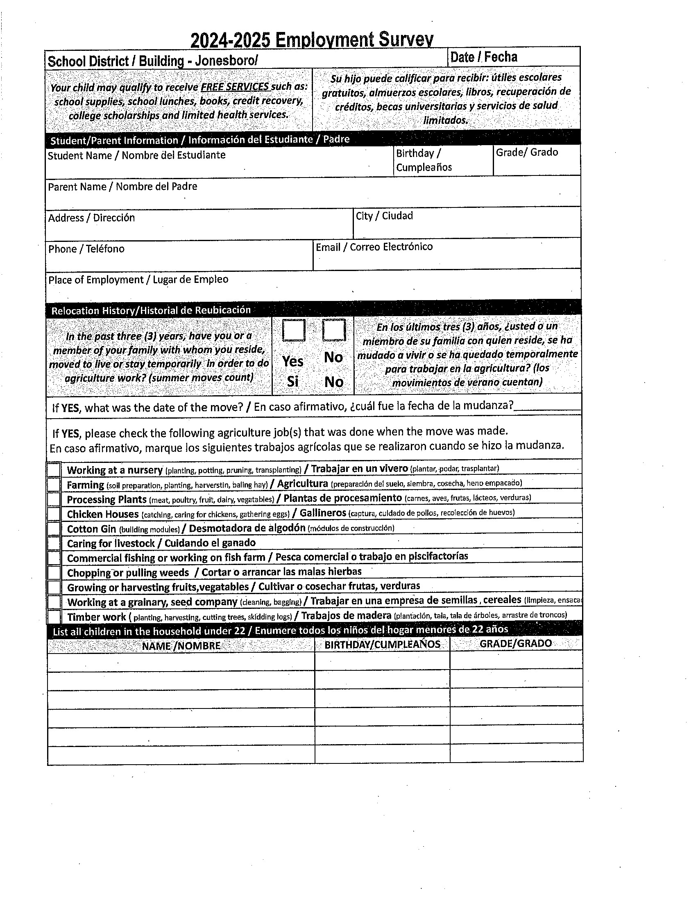

*JPS Pre-Kindergarten Program Page 27*

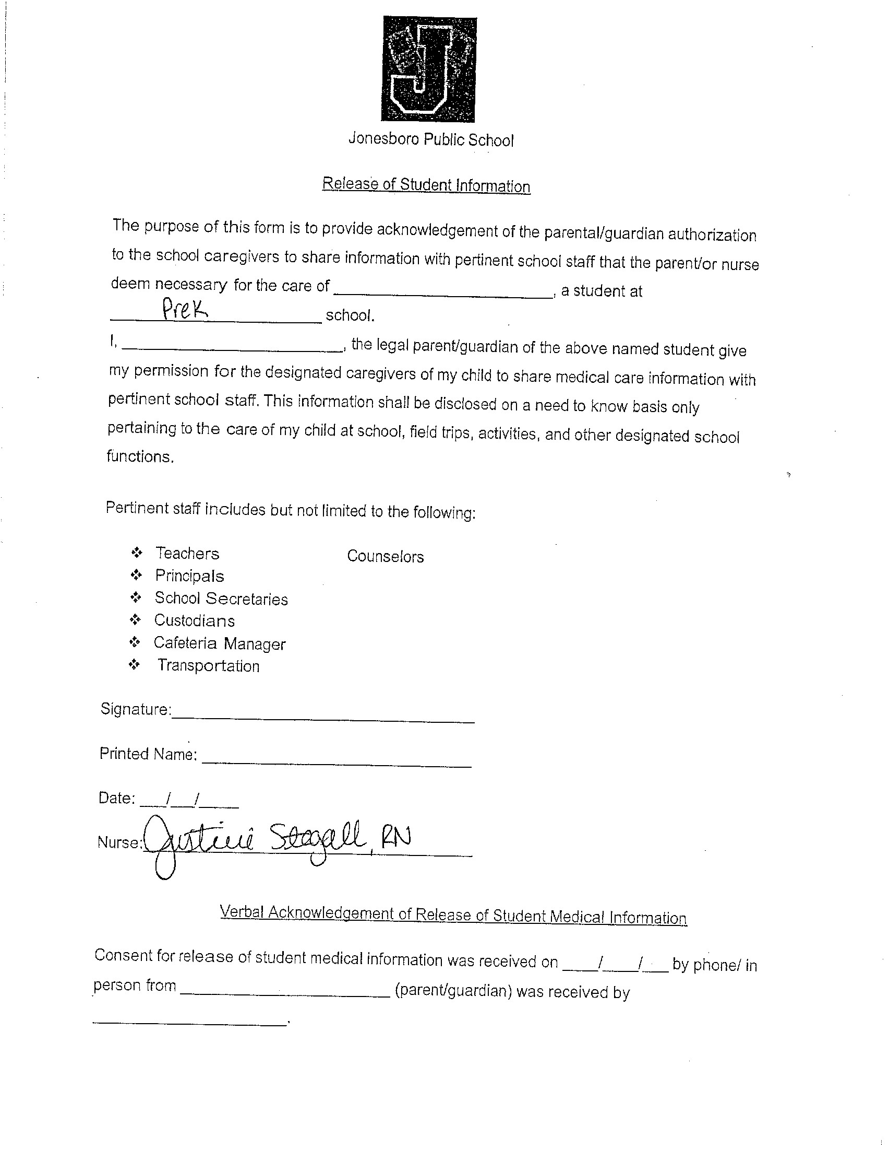



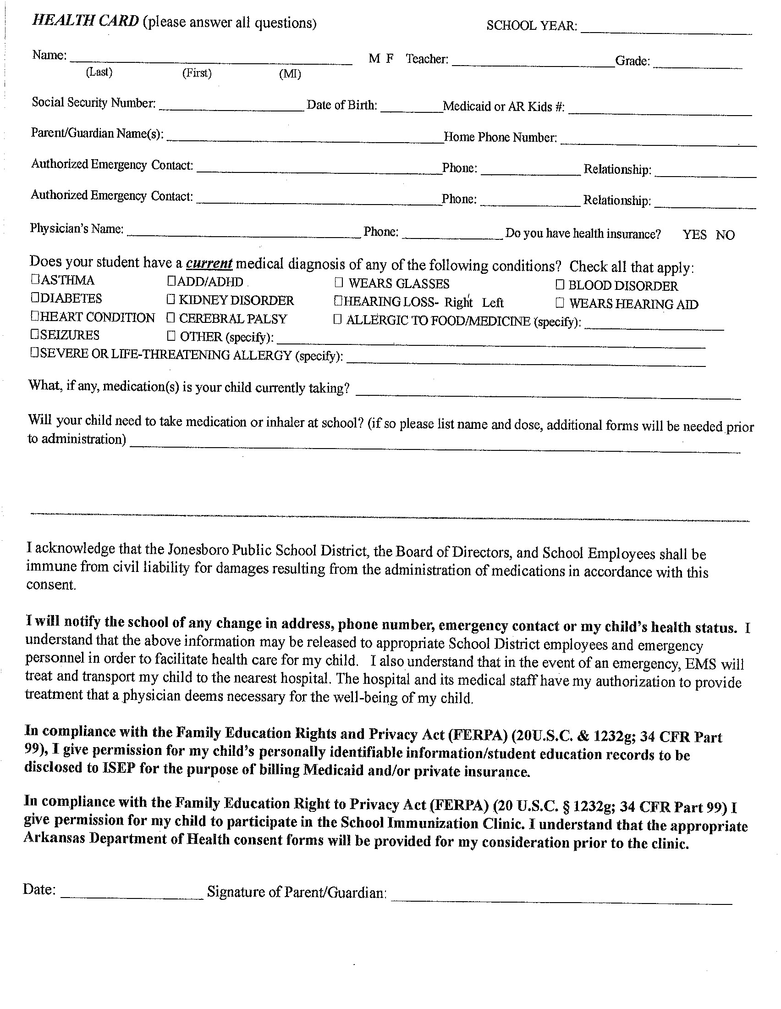

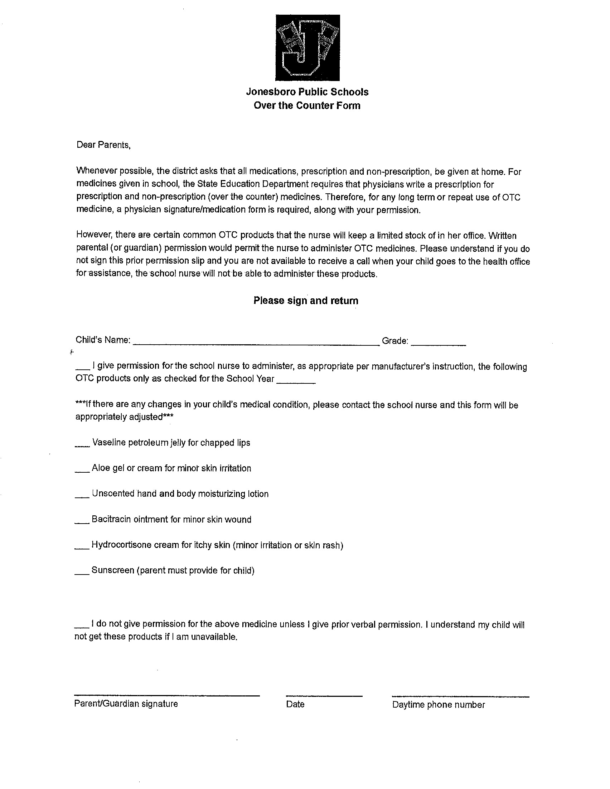



*JPS Pre-Kingergarten Program Page 35*

**MULTIPLE VERTIFICATION AND CONSENT FORM**

**INTERVIEWING CHILDREN**

This is a statement of vertification that I have been informed that Child Care Licensing/Investigators/

Law Enforcement may possibly interview my child. This is in accordance with Minimum Licensing

|  |  |
| --- | --- |
| ________________________________________ | ______________________ |
| Parent Signature | Date |

Requirements/DCCECE/Child Care Licensing Unit: Section 201

$

________________________________________ ______________________

Parent Signature Date

**KINDERGARTEN READINESS SKILLS**

**(For children ages 3 and 4)**

This is to acknowledge that I have received the Kindergarten Readiness Skills Calendar for my child. This is in accordance with Minimum Licensing Requirements: DCCEC/Child Care Licensing Unit:

Section 201

LICENSING

COMPLIANCE FORMS

ARE AVAILABLE FOR

REVIEW UPON

REQUEST.



*JPS Pre-Kingergarten Program Page 37*

Kindergarten Readiness Indicator Checklist for Families

There is much that families and other caregivers can do to support school readiness. School readiness occurs when families, schools, early environments, and communities support and serve ALL children, so they have access to opportunities that promote success in both school and life. Children's skills and development are dependent upon the relationships and interactions they have with the people in their lives before going to kindergarten.

The Kindergarten Readiness Indicator Checklist helps families and caregivers identify a range of skills, knowledge, and behaviors children master as they move through the pre-kindergarten year. Admission to kindergarten is not dependent on mastery of any or all of these indicators. The Arkansas Department of Education and the Arkansas Department of Human Services encourages families and caregivers to use this checklist to help children enter kindergarten with confidence. If you have concerns about your child's development, contact your primary care physician or the county health department in your community.

|  |  |
| --- | --- |
| **Cognitive Development** | |
|  | Exhibits curiosity, interest, and a willingness to explore new things |
|  | Completes a task such as working a puzzle |
|  | Adapts to new situations |
|  | Focuses and pays attention during an activity such as during story time |
|  | Engages in memory games such as, “What’s Missing?” or simple memory activities |
|  | Uses number and letter-like forms or drawings to represent ideas or feelings |

|  |  |
| --- | --- |
|  | **Science and Technology** |
|  | Asks questions about the world around them, for example, “What do plants need to grow?” |
|  | Recognizes that living things change over time, for example, babies grow and become adults, and seedlings grow and become plants |
|  | Describes objects and materials by their physical properties and sorts them based on similarities and differences |
|  | Explores the functionality of digital devices |

|  |  |
| --- | --- |
|  | **Creativity and Aesthetics** |
|  | Expresses themself by singing and moving to the beat and speed of music |
|  | Creates art independently by using a variety of art materials with purpose and planning |
|  | Uses pretend play to process experiences, feelings and roles represented in fantasy or real-life scenarios, such as reenacting a visit to the doctor, pretending to rock a baby, or be a cashier |

|  |  |
| --- | --- |
|  | **Social Studies** |
|  | Knows first and last name, age, and the names and cultural heritage of family members |
|  | Understands and talks about today, yesterday, tomorrow, after lunch, day, and night |
|  | Shows awareness of familiar buildings and places in the community such as home, school, grocery store, and park |

|  |  |
| --- | --- |
|  | **Language Development** |
|  | Understands an increasing number and variety of words for objects, actions, and ways to describe things |
|  | Comprehends who, what, why, and where questions |
|  | Performs up to three-step directions |
|  | Uses four- to six-word sentences |
|  | Tells increasingly detailed stories or ideas |
|  | Communicates clearly enough to be understood by most people |
|  | Takes turns in conversations with others |
|  | Responds to the English language |
|  | Speaks and expresses themself in English |

### Social and Emotional Development

|  |  |
| --- | --- |
|  | Separates from caregiver to another trusted adult |
|  | Takes turns and plays cooperatively with other children |
|  | Expresses basic emotions such as happy, sad, mad, or scared |
|  | Responds sympathetically to others’ distress with words or actions |
|  | Recognizes similarities or differences in interests, ideas, feelings, and abilities between themselves and others, for example, “I can run faster than my friend” or “My dad and I both like to tell stories” |

|  |  |
| --- | --- |
|  | **Mathematical Thinking** |
|  | Says numbers in order up to 20 |
|  | Compares whether the objects in one group are more than, less than, or the same as objects in another group |
|  | Counts objects using one number for each object |
|  | Recognizes four objects in a group without counting |
|  | Recognizes numerals 1-10 |
|  | Sorts objects by color, shape, and size |
|  | Recognizes and repeats patterns such as triangle, square, triangle, square |
|  | Measures and compares the height of objects |
|  | Arranges objects from shortest to longest, for example, shoe sizes or different lengths of yarn |
|  | Recognizes and names familiar shapes such as a square, triangle, circle, or rectangle |
|  | Understands and uses words such as inside, outside, up, down, over, or under |

|  |  |
| --- | --- |
|  | **Emergent Development** |
|  | Listens, tells, and engages in stories being read |
|  | Participates in singing songs and saying rhymes |
|  | Retells stories from favorite books and personal experiences |
|  | Decides if two words rhyme, for example, cat and bat |
|  | Holds a book right-side-up, turns pages front-to-back, follows print left-to-right, and top-to-bottom |
|  | Recognizes and names letters, especially those in their name or on road signs, storefronts, and restaurant signs |
|  | Produces the correct sounds for some of the letters of the alphabet |
|  | Writes some letters correctly, especially those in their name |





A legacy of excellence.